**Tennis Court Management System**

### **1. Problem Statement**

Managing tennis facilities efficiently is critical for ensuring user satisfaction and operational effectiveness. Players and administrators often face challenges such as:

* Difficulty in booking courts due to unorganized reservation systems.
* Inefficient communication about court availability, maintenance schedules, and events.
* Limited tools to manage memberships, coaching sessions, and tournaments.

These challenges often lead to underutilized courts, user dissatisfaction, and operational inefficiencies. A modern, centralized, and user-friendly management system is essential to address these issues.

### **2. Objective**

The primary objective of this project is to develop a **Tennis Court Management System** that allows users to conveniently book courts, participate in events, and manage memberships, while administrators can oversee operations efficiently.

The system will provide:

* Real-time court availability and reservation management.
* Tools for managing memberships, coaching sessions, and tournaments.
* Analytics and reporting for optimizing operations.

By offering a streamlined, intuitive, and feature-rich platform, the system aims to improve user experience and operational efficiency.

### **3. Functional and Non-Functional Requirements**

#### **Functional Requirements**

For Users:

* Account creation, profile management, and login/logout.
* Search and book available courts by time, date, and type.
* Register for coaching sessions and tournaments.
* Make payments for bookings, memberships, and lessons.
* View notifications, booking history, and performance analytics.

For Admins:

* Manage court details, availability, and maintenance schedules.
* Approve, cancel, and reschedule bookings.
* Create and manage membership plans, pricing, and benefits.
* Organize and oversee tournaments and coaching schedules.
* Generate reports on court usage, revenue, and user activity.

#### **Non-Functional Requirements**

* Responsive and user-friendly interface for both users and admins.
* Secure data storage and payment processing to ensure user privacy.
* Scalable architecture to support an expanding user base.
* High availability to minimize downtime and disruptions.

### **4. Use Case Diagram**

*(A visual representation of user interactions with the system can be included here, highlighting key functionalities like booking courts, managing memberships, and admin oversight.)*

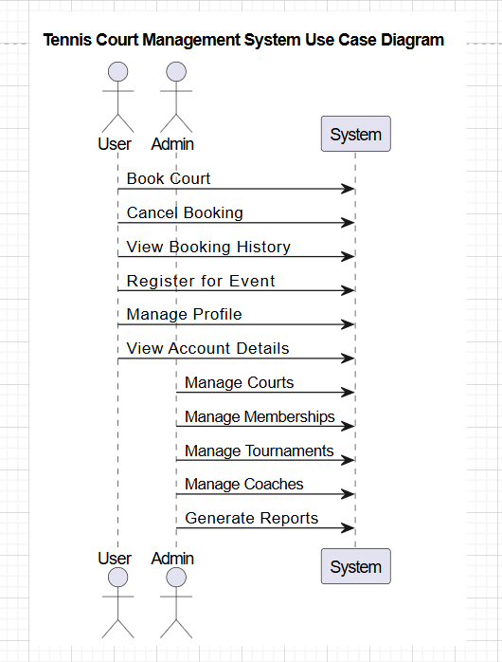

### **5. Database Diagram**

*(Illustrate the database structure, showing entities such as Users, Courts, Bookings, Memberships, Coaches, and Tournaments, along with their relationships.)*

